How to Use docker-compose Environment Variables

If you need to define various configuration values, environment variables are your best friend. Like many tools, Docker and, more specifically, Docker Compose can both define and read environment variables to help keep your configurations clean and modular. This tutorial teaches you how to use docker-compose environment variables to define different containers, environments, and more.

Prerequisites
If you’d like to follow along step-by-step, ensure you have the following:
- A Linux host with admin privileges. This tutorial uses Ubuntu 18.04.5 LTS.
- Docker installed on the Linux host. This tutorial uses Docker v19.03.11.
Related:How to Install and Use Docker on Ubuntu (In the Real World)

Declaring Environment Variables in the Docker Compose File
Containers can demand a lot of configuration. And not every configuration in your containers will be unique. Some settings might be shared across some of your containers, like a MySQL database credential. Store the credentials manually in each container, and when the credentials change, you end up having to update the credentials multiple times.

Environment variables can reduce that hassle. Store those shared settings as environment variables! Reference the environment variables instead of repeating yourself in the containers. When the credentials change, you have to update just one setting: the environment variable.
Let’s start by declaring an environment variable and storing it in the Docker Compose file itself. The steps below will store settings for a hypothetical MySQL database in environment variables.

1. Open a terminal on your local machine.
2. Create a folder named ~/docker-compose-demo, then change (cd) the working directory to the folder you just created. The ~/docker-compose-demo folder will contain all of the files you’ll create in this tutorial.
mkdir ~/docker-compose-demo
cd ~/docker-compose-demo
3. Open your favorite text editor, copy/paste the code in the snippet below in the text editor. Save the file as docker-compose.yml inside the ~/docker-compose-demo directory. The docker-compose.yml stores the configurations for your application’s services.

In the snippet code below:
- mysql:5.7 is the base image that Docker Compose pulls and creates a new container.
- MYSQL_ROOT_PASSWORD, MYSQL_ALLOW_EMPTY_PASSWORD, and MYSQL_RANDOM_ROOT_PASSWORDare three different environments variables within the Docker Compose file. Each environment variable is declared with its values. The value the environment variable gets comes after the: symbol.
- mysql service will create the container named mysql.
# Version of Docker compose file
version: "2.2"

services:
# Defining the service
mysql:
# Defining the base image to be used
image: mysql:5.7
hostname: mysql
container_name: mysql
# Defining the environmental variable
environment:
# ENVIRONMET_VARIABLE_NAME: "environment variable value"
MYSQL_ROOT_PASSWORD: "root_password"
MYSQL_ALLOW_EMPTY_PASSWORD: "password"
MYSQL_RANDOM_ROOT_PASSWORD: "password"

Some containers rely on environment variables to work properly. The one in the example, MySQL, is one of these containers. If you don’t declare the environment variables the container is expecting, it will throw an error. You can see the error below.
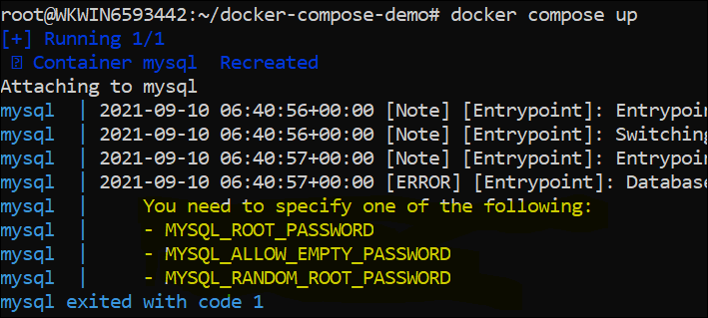

4. Next, execute the docker-compose up command. The docker-compose up command reads the YAML file (docker-compose.yml) created in the previous step and creates the container. The docker-compose up command starts all the services configured in the Docker Compose file.
5. Now, verify if all three environment variables are present in the container by running the docker exec command and the env command.
Running the docker exec command will allow you to log in to the container. Running env will print the list of the current environment variables with their respective values.
# ee8a... is the container
docker exec -it ee8af8bfcd41 /bin/bash

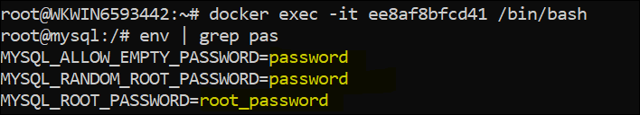

Substituting the Environment Variables
In the previous section, you learned how to declare the environment variables directly within the Docker Compose file by hard coding them. Such an approach is not optimal if you need to secure your credentials. As an alternative, store the values for environment variables in a file named .env that only the admin can read.

Let’s practice using substitution for environment variables. In your terminal:
1. Create a file named .env in the same ~/docker-compose-demo directory and copy the code below in the .env file. The file will have all the environment variables with their respective values.
# Defining the values of environmental variables
MYSQL_ROOT_PASSWORD="root_password"
MYSQL_ALLOW_EMPTY_PASSWORD="password"
MYSQL_RANDOM_ROOT_PASSWORD="password"
2. Next, edit the permissions of the .env file you created in the previous step using the setfacl command. The command below ensures that the root user has read/write permissions to the .env file.

- m parameter allows you to set the permissions to the files/folders.
- u is the user (root) which will have permissions granted to the specified file ~/*docker-compose-demo/.env
setfacl -m "u:root:rw" ~/docker-compose-demo/.env
3. Next, edit open the docker-compose.yml file with your favorite editor and comment out the environment section in the docker-compose.yml from the previous section. Add the code below to set default values for the environment variables in the Compose file.
Docker sets the values via the command line or by reading files, such as the .env file in the example. In either case, Docker replaces the values accordingly.
# Defining the environmental variable using Hardcoded values in variables
environment:
### Static way ###
# MYSQL_ROOT_PASSWORD: "root_password"
# MYSQL_ALLOW_EMPTY_PASSWORD: "password"
# MYSQL_RANDOM_ROOT_PASSWORD: "password"

### Substitution ###
MYSQL_ROOT_PASSWORD: ${MYSQL_ROOT_PASSWORD}
MYSQL_ALLOW_EMPTY_PASSWORD: ${MYSQL_ALLOW_EMPTY_PASSWORD}
MYSQL_RANDOM_ROOT_PASSWORD: ${MYSQL_RANDOM_ROOT_PASSWORD}

The code defines the variables by applying the string interpolation method. Variables with string interpolation are declared as ${variable}. Docker sets the values of the environment variables at run time.
4. Again, execute the docker-compose up command. When you run the docker-compose up command, the docker-compose.yml file looks for the values of the environment variables in the .env file. The docker-compose command automatically looks for a .env file in the project directory or in the parent folder of your compose file.
As soon as docker-compose finds the value for the environment variables set in docker-compose.yml in the .env file, Compose substitutes the values accordingly and starts the service. Staring the service creates the container defined in the docker-compose.yml file.

Using Multiple Environment Variables Files for Multiple Environments
Up to now, you have learned two approaches to declare the environment variables. The first one is to declare environment variables within the docker-compose.yml file. The second approach is declaring the environment variables within a single .env file and applying substitution.
Both approaches are suitable when working with a single environment. If you have multiple environments, like Production and/or Testing, you need a different approach. Let’s check out how to create multiple .env files with different names to match your environments!

The example below will emulate the usual environments one might encounter in IT Ops: Dev, QA, and Prod. Back on your terminal:
1. Navigate to your ~/docker-compose-demo directory and create a .env.dev file. Copy/paste the content of the snippet code below in the file and save it. This file will hold the settings use for your MySQL development environment database.
# Enviornmental Variables file .env.dev
MYSQL_ROOT_PASSWORD="password_DEV"
MYSQL_ALLOW_EMPTY_PASSWORD="password1"
MYSQL_RANDOM_ROOT_PASSWORD="password1"
2. On the same directory, create a .env.qa file and save the contents of the snippet code below in the file. These are the settings for your MySQL quality assurance environment database.

# Enviornmental Variables file .env.qa
MYSQL_ROOT_PASSWORD="password_QA"
MYSQL_ALLOW_EMPTY_PASSWORD="password2"
MYSQL_RANDOM_ROOT_PASSWORD="password2"
3. Now create a .env.prod file to store the settings for the hypothetical MySQL production environment database. The contents are below:
# Enviornmental Variables file .env.prod
MYSQL_ROOT_PASSWORD="password_PROD"
MYSQL_ALLOW_EMPTY_PASSWORD="password3"
MYSQL_RANDOM_ROOT_PASSWORD="password3"

4. Next, execute the docker-compose command with the --env-file option, specifying the .env.dev file. The docker-compose command looks for the .env.dev file in the current ~/docker-compose-demo directory.
docker-compose --env-file .env.dev up
Passing the file as an argument allows you to store the file anywhere and with an appropriate name.
Related:Use Docker Stop Containers Without Screwing Things Up!
As you can see below, you can easily pick the different environment files and deploy them by replacing the .env.dev file to either the .env.qa or the .env.prod file.

# Running the docker-compose command with the QA file
docker-compose --env-file .env.qa up
# Running the docker-compose command with the Prod file
docker-compose --env-file .env.prod up
5. Now, verify if the configuration file (.env.dev) has been successfully read by running the docker exec command. Running the docker exec command will allow you to log in to the container. Running env will print the list of the current environment variables.
Notice that all three environment variables (MYSQL_ROOT_PASSWORD, MYSQL_ALLOW_EMPTY_PASSWORD, and MYSQL_RANDOM_ROOT_PASSWORD) are present in the container. Notice that their values come from the env.dev file.
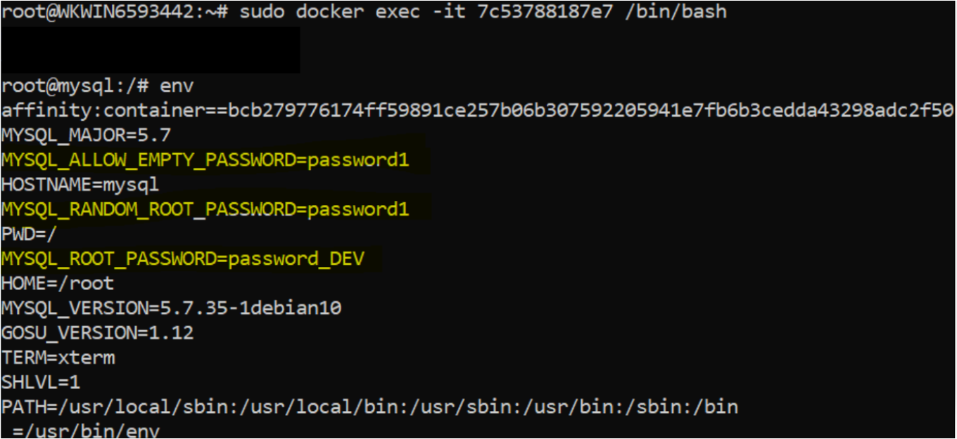.env.dev file

Incorporating the env_file in the Docker Compose File
In the previous section, you saw how to declare the environment variables in .env files. When you store environment variables values in the .env file separately, you end up with lots of lines and references in the docker-compose.yml.
To reduce the references and the number of lines for environment variables in the docker-compose.yml file, consider incorporating the env_file in your docker-compose.yml file.
Let’s learn how to incorporate the env_file in the Docker compose file. Once again, in the terminal:
1. Create a file named var.env to hold the settings for your MySQL database. Copy/paste the following into the var.env file and save it to the same ~/docker-compose-demo directory.
MYSQL_ROOT_PASSWORD="password_NEW"
MYSQL_ALLOW_EMPTY_PASSWORD="password_NEW"
MYSQL_RANDOM_ROOT_PASSWORD="password_NEW"
2. Next, open the previously created docker-compose.yml file using your favorite editor. Replace the environment section from the docker-compose.yml that you created previously with env_file, and add the file’s path with - ./var.env.
Docker now looks for the ./var.env file in the same ~/docker-compose-demo directory.
version: "2.2"

services:
mysql_svc:
image: mysql:5.7
hostname: mysql
container_name: mysql
# Replacing the environment: with env_file:
# environment:
# MYSQL_ROOT_PASSWORD: ${MYSQL_ROOT_PASSWORD}
# MYSQL_ALLOW_EMPTY_PASSWORD: ${MYSQL_ALLOW_EMPTY_PASSWORD}
# MYSQL_RANDOM_ROOT_PASSWORD: ${MYSQL_RANDOM_ROOT_PASSWORD}
env_file:
- ./var.env
Notice that all of the three settings and references are now gone. You are left with a single reference. It may not seem like much in the example. But in the real world, the number of references can get out of hand real quick.
3. Next, execute the docker-compose command. The command looks for the values of the environment variable present in the var.env file and creates the container you defined in the docker-compose.yml file.
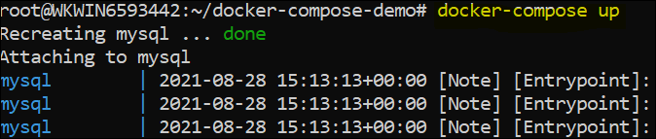docker-compose starts the service.
Docker creates the services, meaning that the Docker found the values for the environment variables in the var.env file. To confirm, run the docker exec and the env commands one last time. You will see all the environment variables (MYSQL_ROOT_PASSWORD, MYSQL_ALLOW_EMPTY_PASSWORD, and MYSQL_RANDOM_ROOT_PASSWORD) and their values in the container.

Conclusion
In this tutorial, you learned different ways of declaring environment variables with Docker compose. The article showed you the great flexibility Docker allows in declaring the environment variables by either coding them directly or using them with separate files.
So which approach are you going to use next while running your Docker containers from Docker Compose?
https://adamtheautomator.com/docker-compose-environment-variables/

A complete guide to using environment variables and files with Docker and Compose

Keep your containers secure and flexible with this easy tutorial

Ales krivec on Unsplash)
Environment variables keep your app secure and flexible. This article will demonstrate that it’s easy to pass both individual variables and files that contain multiple Docker containers. If your app needs to connect to a database this would be the ideal place to store the database connection details. Advantages:
- Keeping all confidential information in one file; we can .gitignore all of it
- an env file can be “injected” in multiple containers; all configurations in one place
- Keep your Docker images safe; don’t build your image with confidential information baked into it
- We can just restart our running container with new environment variables instead of rebuilding our entire container with new variables.
This way you can simply restart your container when your database password changes. Obviously, we are going to use Docker and Docker-Compose for this. It’s recommended to first read this and this article if you’re unfamiliar with either.
First, we’ll create a container to pass the environment variables to. Then we’ll check out all the ways we can pass them. Let’s code!

Setting up
We’ll create a simple Python script called environprinter.py that prints our all keys and values in our environment:
We’ll bake this file in a simple docker image with the Dockerfile below.
First, call this image environ_image. We build it with docker build . -t environ_image. Remember that this image simply contains a Python script that does nothing more than print all environment variables in our system.
When we spin up this container by executing docker run environ_image it prints all environment variables. You’ll see that there are always some environment variables that concern your path, hostname etc. (more about in this article).

Barrett Ward on Unsplash)

Passing environment variables
Let’s start up easy; first we’ll pass some variables. Later we’ll look into how to make this more dynamic.

1. Passing some environment variables with Docker run
The simplest way to pass an environment variable with Docker run is with the -e flag. We’ll pass the value myvalue to the environment. We need to specify a key for this as well: MYKEY:
docker run -e MYKEY=myvalue environ_image
Notice that MYKEY and myvalue now show up in the output! You can access these environment variables from anywhere in the container.

2. Passing an environment variable with Docker Compose
We can take the docker run the configuration that we’ve defined above and put in a docker-compose file.
Executing the compose file below does nothing more than the command above; spinning up the environ_image and passing two environment variables. You can execute this file with docker-compose up.

Alex Litvin on Unsplash)

Using environment files
In this part, we’ll keep all of our environment variables in a single file. The file is called .env (no name; just an extension). In this file, we’ll keep a simple list of keys and values. Our file looks like this:
THE_LABEL="label 1"
USERNAME="mike huls"
Next, we’ll use this file in our docker-compose configuration.

1. Passing a env file to container using compose
Our goal is to pass the entire content of the .env file to our image. We do this with the docker-compose file below:
Now we can just docker-compose up. Notice that all keys and values from our env file now are accessible in our Python file. Easy!

2. Passing an env file to docker-compose
We can also specify variables in the docker-compose file that get filled in with values from the .env file. Check out this example: we want our container to have a label that’s specified in the .env file.
In order to do this, we define a variable in the compose file in the following format: ${ENV_KEY}. When we spin up our container Docker will replace the variable by the value of the env variable as specified by the key:
The code above looks for a key called ‘THE_LABEL’ in the .env file we’ve created earlier and replaces it with the value if it can find one. You can check out the output of this process with
docker-compose --env-file .env config
This way we can dynamically pass values to the docker compose file. Spin up your container with docker-compose --env-file .env up.

Using multiple env files
Notice that passing an env file to the image and passing an env file to the docker-compose configuration are two different things. In the example below we do both with two different .env files. One is called label.env, the other is called python.env. The content of these files is irrelevant for now:
We spin up this container with: docker-compose --env-file label.env up.
As you see we specify the python.env to be passed to the container while we use the label.env file for configuring the compose file.

Conclusion
I hope to have shed some light on how to make Docker more secure and convenient to use. Environment variables help you keep all your confidential information in one place, you avoid baking it into your image and it makes running containers even more dynamic.
If you have suggestions/clarifications please comment so I can improve this article. In the meantime, check out my other articles on all kinds of programming-related topics like these:
- Docker for absolute beginners
- Docker Compose for absolute beginners
- Turn Your Code into a Real Program: Packaging, Running and Distributing Scripts using Docker
- Use git submodules to install a private, custom python package in a docker image
Happy coding!
— Mike
P.S: like what I’m doing? Follow me!
https://towardsdatascience.com/a-complete-guide-to-using-environment-variables-and-files-with-docker-and-compose-4549c21dc6af

How to Use Environment Variables in Docker Compose
Ever wondered how you can easily (and securely) customize Docker? Look no further.
Sooner or later, we all have to deal with environment variables in our Compose files. They can become a pain, especially if we don’t know how to use them properly. Here’s everything I know about environment variables and how to make using these variables easy and, above all, secure.
Want More Software Development Tutorials?4 Python Tools to Simplify Your Life

How Do We Use Environment Variables?
Docker Compose allows us to pass environment variables in via command line or to define them in our shell. However, it’s best to keep these values inside the actual Compose file and out of the command line. “Why?” you may ask.
Because this way, we don’t have to remember all of the environment variables we use every time we deploy our container. By storing them in the Compose file, we maintain consistency during our builds.
There are several ways to do this.

Use the Environment Option
Using the Compose environment option allows us to declare environment variables and their values inside our Compose file, like this.
This is the easiest, quickest way to store environment variables inside Compose files. However, it has a huge drawback and it’s related to security. Can you guess what it is?
That’s right.
Storing the values of your environment variables in the Compose file will — 95 percent of the time — go straight to source control and that’s a huge security risk. Luckily, we have an alternative: using an external file to store our environment variables.

Use a .env File
The main advantage of using an external file for your environment variables is that you can keep said file out of your source control. After all, no one enjoys having their passwords, API keys or other super-secret information all over the internet.
.env files are plain text files, which we use for configuration. Remember, because the file name begins with a ‘.’, they remain hidden to the system.
Tip: To list hidden files, you can use the ls -a command on Linux, or the dir /a:h command on Windows.
You must create .env files at the root of your project, which is also where your docker-compose.yml file should be.
We can declare and assign variables in our .env file. Name the variables however you want since we’ll only access their values.
Here’s my .env file:
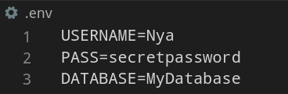
You can also create and populate your .env file from the command line, by using the Linux cat command:
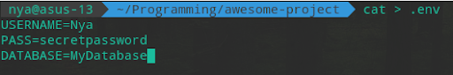
Tip: Remember not to leave any spaces between the = sign and the value assigned to your variable, as they will be added to the string.
Now that we have our variables stored in our .env file, let’s use them in our Compose file. Now’s the time to use string interpolation (that’s a fancy name for using the notation ${string}) to assign the values of our .env variables to the environment variables in the Compose file.
As you can see, we maintain the environment option and simply assign our external values to the Compose environment variables.
To check that everything’s working properly, run the following command: docker-compose up.
Tip: You can check which values are assigned to the environment variables by running the following command (in a different terminal): docker-compose config.

Why Use Environment Variables in Docker Compose?
Docker Compose allows us to pass environment variables in via command line or to define them in our shell. However, it’s best to keep these values inside the actual Compose file and out of the command line. “Why?” you may ask. Because this way, we don’t have to remember all of the environment variables we use every time we deploy our container. By storing them in the Compose file, we maintain consistency during our builds.
Stay Up-to-Date With Developments in DevelopingTest-Driven Development Is Still Alive and Well

Environment Variable Priority
Something very important we must keep in mind is the priority used by Compose to choose its environment value. What does this mean?
If we declare the same environment variable in several files (e.g, in the Compose file and in the external .env file) with different values, Compose will use the value of the variable declared in the Compose file. Why? Because, depending on where the variable is declared, Compose gives that variable a higher or lower priority. Here’s the order, ranking from highest priority to lowest:
- Compose file
- Shell environment variables
- Environment file
- Dockerfile
- Variable is not defined
If, for some reason, Compose is picking up and assigning a value you weren’t expecting, this is probably the cause. Make sure to have all your variables declared exactly where you want.

Use the env_file Option
In the previous section, we talked about plain .env files, but we never got around to using named .env files. If we do want our .env file to have a name, like secret-stuff.enf, Compose has a nifty little option named env_file.
This option allows us to tell Compose which .env file it has to look for, as opposed to its default behavior, which is to look for an unnamed .env file. This is how we use the env_file option.
As you can see, we added the env_file option, which points to a file named secret-stuff.env file. All that’s left is to rename our previous .env file to secret-stuff.env.
You may have noticed the environment option is no longer present in our Compose file. This is because using the env_file option raises a problem — one that gave me quite a headache!
To assign values declared in an external named .env file to Compose variables requires said file to be defined in the primary Compose service. This is related to the order that Compose follows when performing operations. However, we have no primary service, since we are only using a db service. Therefore, if we try to deploy our Compose file, it will complain our variables are undefined, and substitute them with blank strings.
You don’t have to take my word for it, go ahead and try it! Run docker-compose up and see what happens.
So, how do we solve this problem? Here’s what I figured out:
If we remove the environment option from the Compose file, upon deployment, Compose will search for the specified secret-stuff.env file, something it doesn’t do when the environment option is present. Problem solved!
Bear in mind though, since we don’t have the environment option any longer, we must declare the environment variables directly in the secret-stuff.env file, like this:
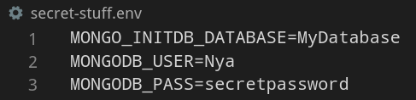
Once again, to check that everything works properly, run: docker-compose up.
That’s all, folks! By now you’ve (hopefully!) learned the different ways of securely dealing with environment variables in Compose files.

